**Data Collection and Preprocessing Phase**

|  |  |
| --- | --- |
| Date | 15 March 2024 |
| Team ID | 739675 |
| Project Title | Cleantech: Transforming Waste Management With Transfer Learning |
| Maximum Marks | 2 Marks |

**Data Collection Plan & Raw Data Sources Identification**

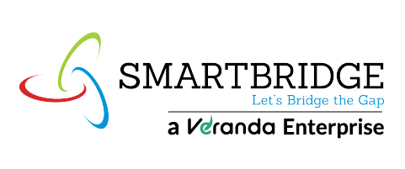**Data Collection Plan**

|  |  |
| --- | --- |
| **Section** | **Description** |
| Project Overview | Cleantech innovations are revolutionizing waste management by integrating advanced machine learning techniques, particularly transfer learning, to enhance efficiency and sustainability. Transfer learning leverages pre-trained models, enabling effective waste classification even with limited datasets |
| Data Collection Plan | To develop a transfer learning-based waste classification model, the data collection plan involves gathering a diverse dataset of labeled waste images across categories like plastic, metal, glass, paper, and organic waste. |

**Raw Data Sources**

|  |  |  |  |  |  |
| --- | --- | --- | --- | --- | --- |
| **Source**  **Name** | **Description** | **Location/URL** | **Format** | **Size** | **Access Permissions** |
| Kaggle  Cleantech  Transforming  Waste  Management  Dataset | A dataset containing labelled Transforming waste management images (e.g.,Plastic, Municipal).. | <https://www.kaggle.com/datasets> | Image | 2 GB | Public |